Παράρτημα ε

Ενδεικτικό φωτογραφικό υλικό από την ψηφιακή βιβλιοθήκη της EUROPEANA

Πηγή: Europeana
http://www.europeana.eu/portal/record/2026004/verk_E_3474.html?start=11&query=breakfast&startPage=1&qt=false&rows=96

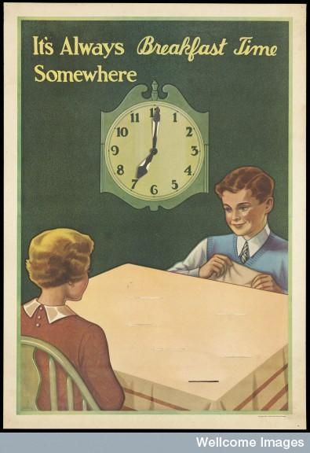
Πηγή: Europeana
http://www.europeana.eu/portal/record/9200105/BibliographicResource_3000006156266.html?start=32&query=breakfast&startPage=1&qt=false&rows=96
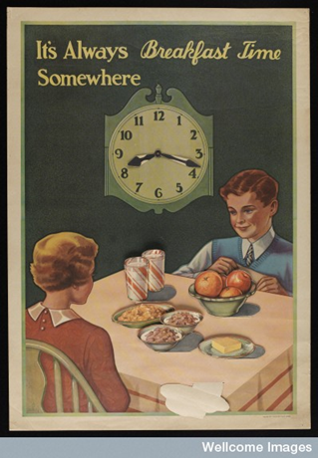
Πηγή: Europeana http://www.europeana.eu/portal/record/9200105/BibliographicResource_3000096347694.html?start=138&query=breakfast&startPage=97&qt=false&rows=96

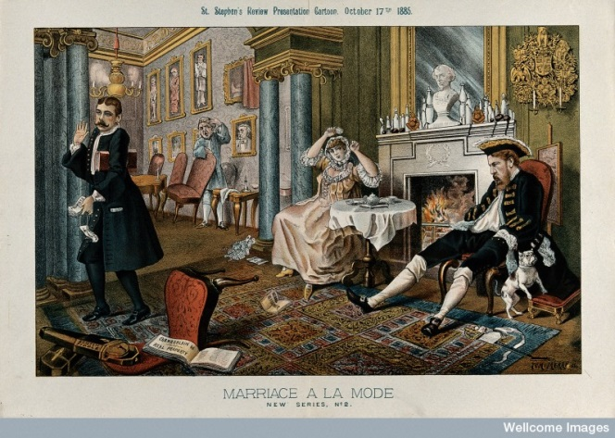
Πηγή: Europeana http://www.europeana.eu/portal/record/9200105/BibliographicResource_3000096349399.html?start=36&query=breakfast&startPage=1&qt=false&rows=96

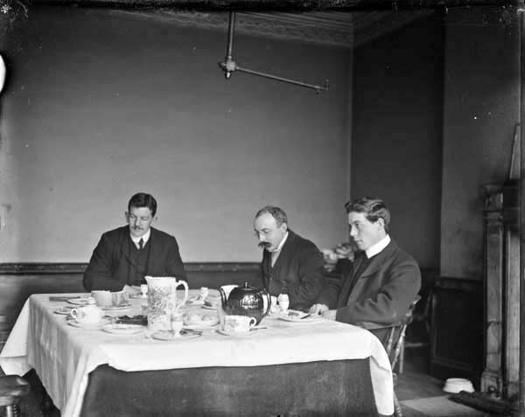
Πηγή: Europeana http://www.europeana.eu/portal/record/92022/BibliographicResource_1000125961394.html?start=57&query=breakfast&startPage=1&qt=false&rows=96

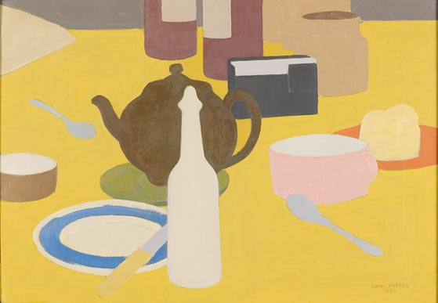
Πηγή: Europeana http://www.europeana.eu/portal/record/2022326/04D7027F466B61EC0A27C3A03C50F2DBC8E5D9F5.html?start=62&query=breakfast&startPage=1&qt=false&rows=96

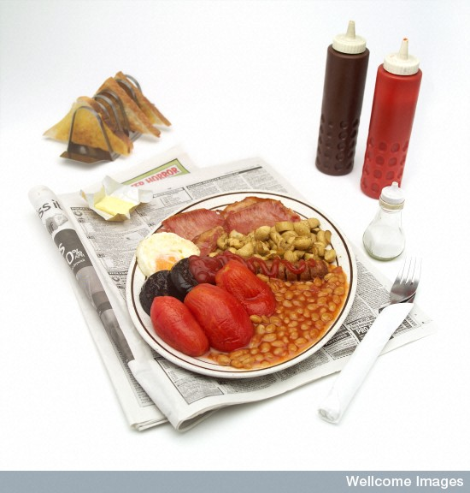
Πηγή: Europeana http://www.europeana.eu/portal/record/9200104/BibliographicResource_3000006312640.html?start=116&query=breakfast&startPage=97&qt=false&rows=96
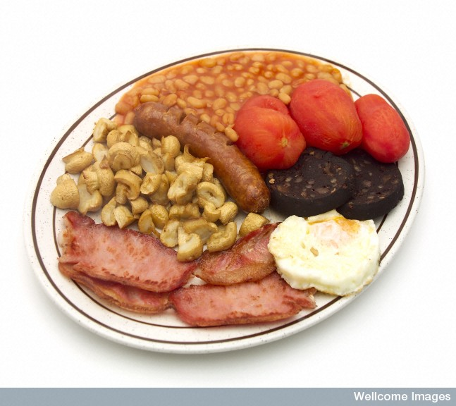
Πηγή: Europeana http://www.europeana.eu/portal/record/9200104/BibliographicResource_3000006312434.html?start=118&query=breakfast&startPage=97&qt=false&rows=96

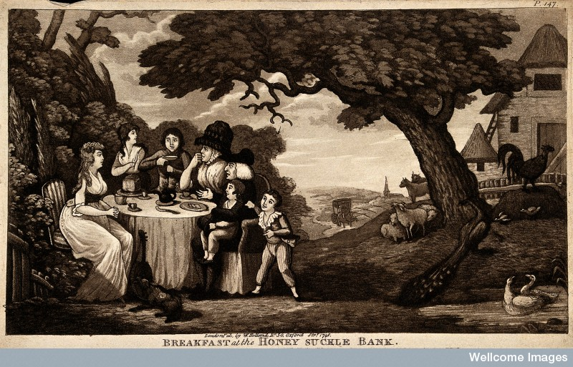
Πηγή: Europeana http://www.europeana.eu/portal/record/9200105/BibliographicResource_3000006127161.html?start=135&query=breakfast&startPage=97&qt=false&rows=96

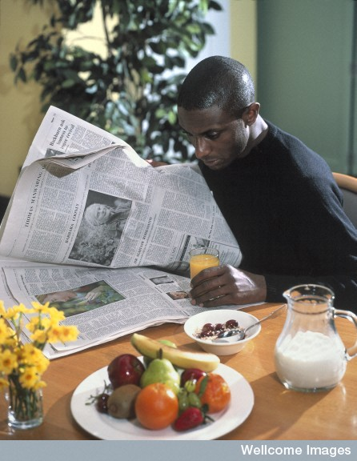
Πηγή: Europeana http://www.europeana.eu/portal/record/9200104/BibliographicResource_3000006302284.html?start=175&query=breakfast&startPage=97&qt=false&rows=96
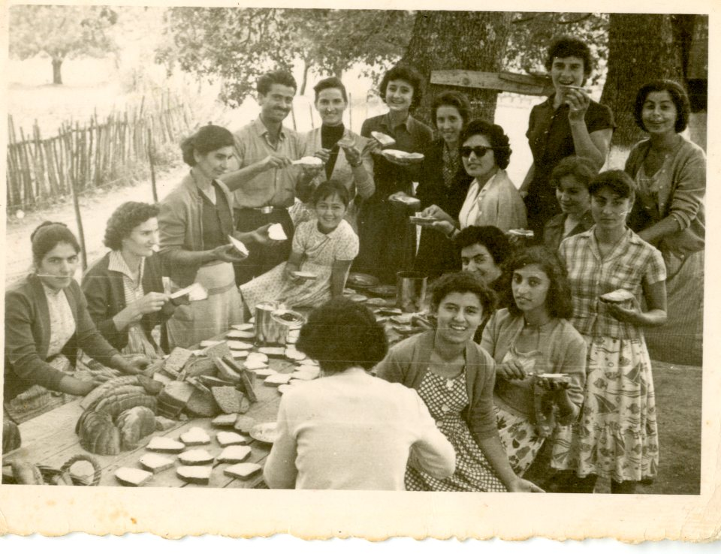
Πηγή: Europeana http://www.europeana.eu/portal/record/2055733/handle_123456789_5346.html?start=253&query=breakfast&startPage=193&qt=false&rows=96

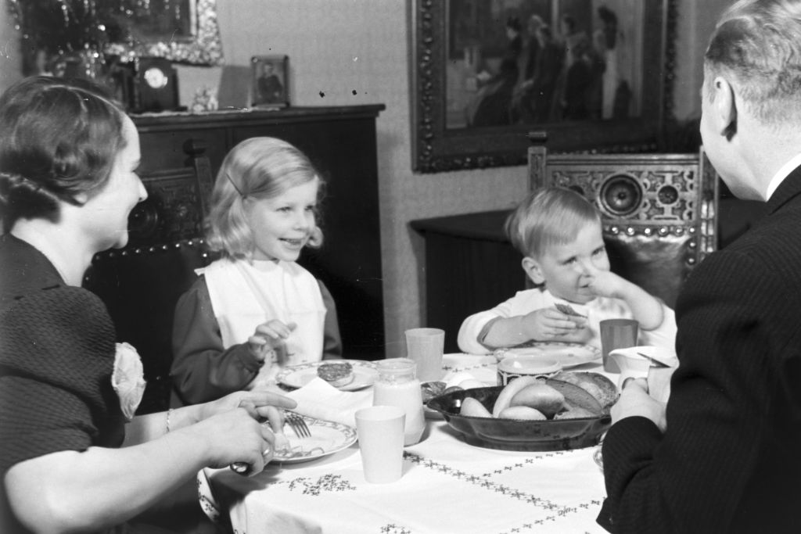
Πηγή: Europeana http://www.europeana.eu/portal/record/2024909/photography_ProvidedCHO_United_Archives_02188795_jpg.html?start=494&query=breakfast&startPage=481&qt=false&rows=96
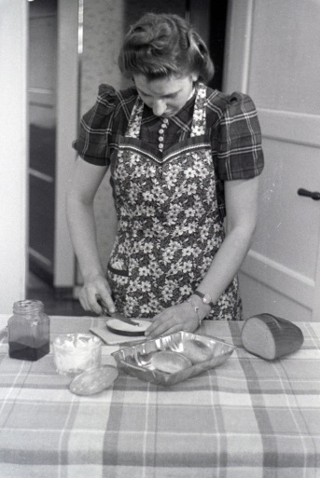
Πηγή: Europeana http://www.europeana.eu/portal/record/2024909/photography_ProvidedCHO_United_Archives_01968511_jpg.html?start=507&query=breakfast&startPage=481&qt=false&rows=96

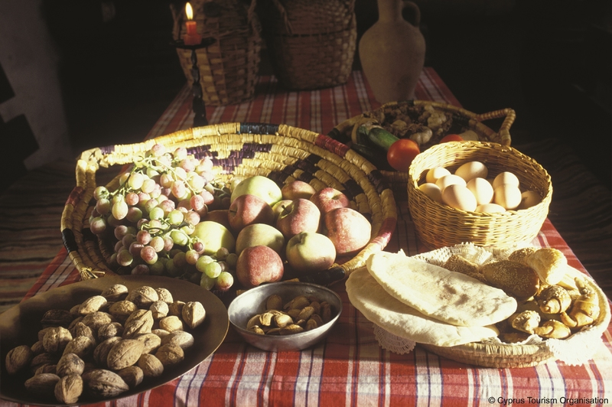
Πηγή: Europeana http://www.europeana.eu/portal/record/2058601/object_CUT_5361669.html?start=387&query=cyprus&startPage=385&qt=false&rows=96

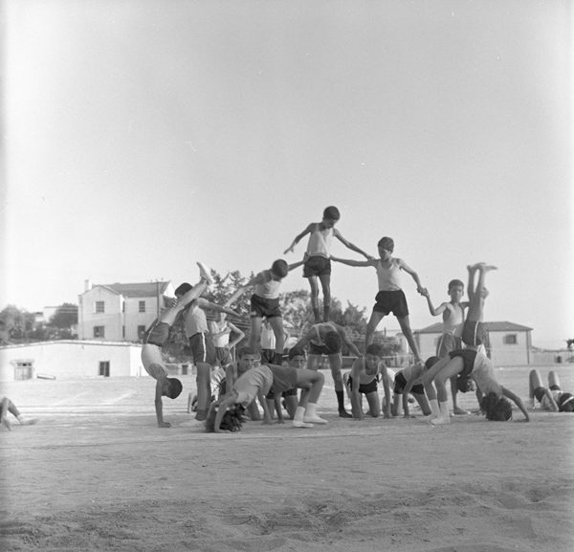
Πηγή: Europeana http://www.europeana.eu/portal/record/2058601/object_CUT_5358384.html?start=147&query=what%3Acyprus+press+and+information+office&startPage=145&qt=false&rows=24

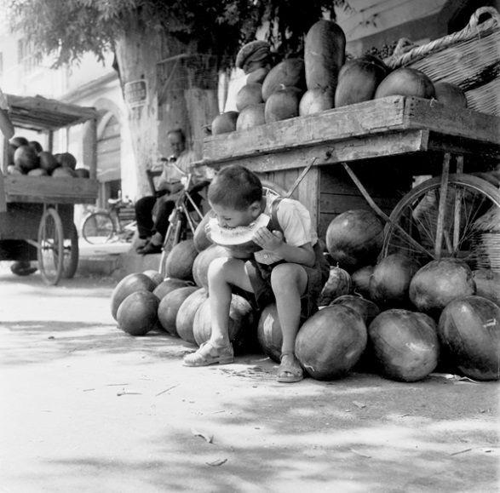
Πηγή: Europeana http://www.europeana.eu/portal/record/2058601/object_CUT_5358522.html?start=153&query=what%3Acyprus+press+and+information+office&startPage=145&qt=false&rows=24
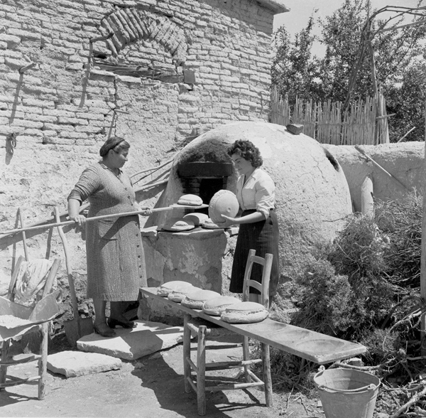
Πηγή: Europeana http://www.europeana.eu/portal/record/2058601/object_CUT_5358526.html?start=202&query=what%3Acyprus+press+and+information+office&startPage=193&qt=false&rows=24

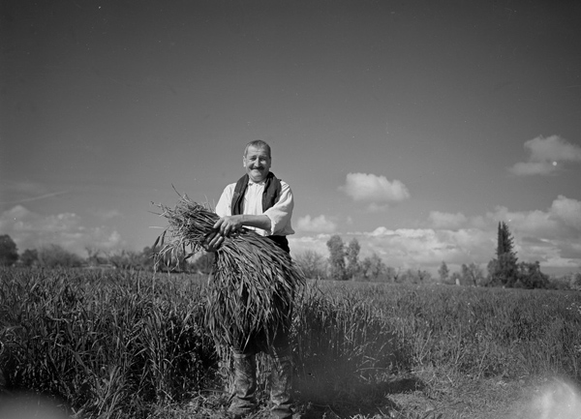
Πηγή: Europeana http://www.europeana.eu/portal/record/2058601/object_CUT_5358276.html?start=219&query=what%3Acyprus+press+and+information+office&startPage=217&qt=false&rows=24
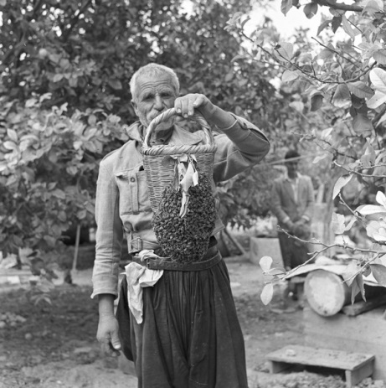
Πηγή: Europeana http://www.europeana.eu/portal/record/2058601/object_CUT_5358280.html?start=294&query=what%3Acyprus+press+and+information+office&startPage=289&qt=false&rows=24

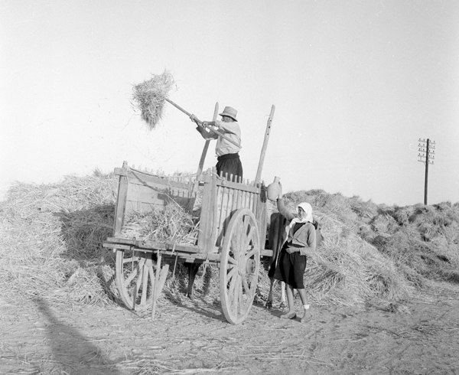
Πηγή: Europeana http://www.europeana.eu/portal/record/2058601/object_CUT_5358523.html?start=311&query=what%3Acyprus+press+and+information+office&startPage=289&qt=false&rows=24
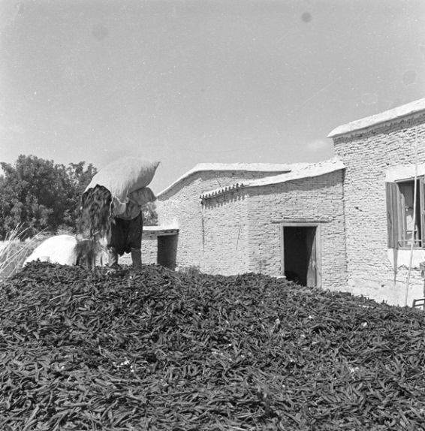
Πηγή: Europeana http://www.europeana.eu/portal/record/2058601/object_CUT_5358282.html?start=94&query=what%3Acyprus+press+and+information+office&startPage=73&qt=false&rows=24

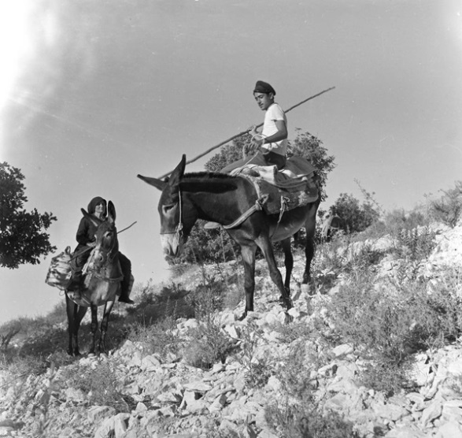
Πηγή: Europeana http://www.europeana.eu/portal/record/2058601/object_CUT_5358282.html?start=94&query=what%3Acyprus+press+and+information+office&startPage=73&qt=false&rows=24

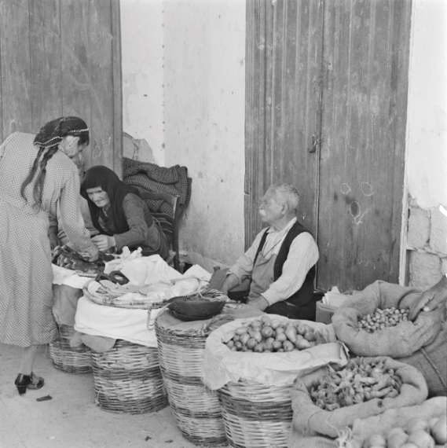
Πηγή: Europeana http://www.europeana.eu/portal/record/2058601/object_CUT_5358406.html?start=133&query=what%3Acyprus+press+and+information+office&startPage=121&qt=false&rows=24

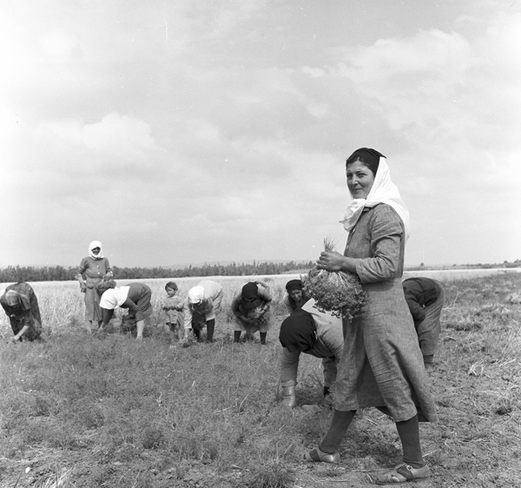
Πηγή: Europeana http://www.europeana.eu/portal/record/2058601/object_CUT_5358296.html?start=157&query=what%3Acyprus+press+and+information+office&startPage=145&qt=false&rows=24
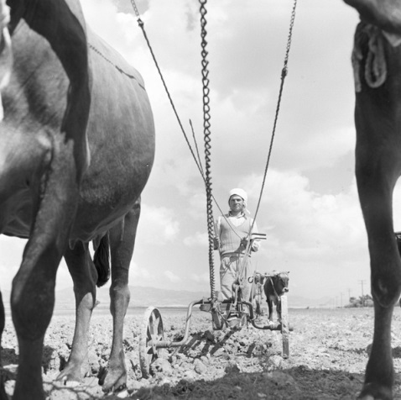
Πηγή: Europeana http://www.europeana.eu/portal/record/2058601/object_CUT_5358303.html?start=176&query=what%3Acyprus+press+and+information+office&startPage=169&qt=false&rows=24

